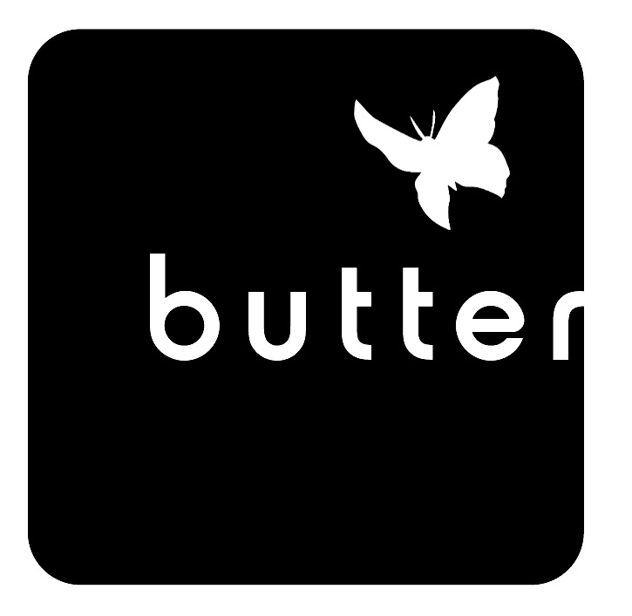
post on bakery whiteboard
BAKERY PRE-ORDERS – SPECIAL ORDERS

TODAY’S DATE ________________taken by______

NAME __________________________________
Phone number ____________________________ email ____________________________________

Day / Date Wanted ___________________________
Pick up Time _________________________________

___ paid ____ pay at pick up ___ invoice #________
note if there are Cafe or Kitchen orders also Y / N
*For large orders, place at least 3 days prior to pick-up
*info? Rebecca-- bakerymanager@butterbakerycafe.com

MORNING PASTRIES / ASSORTED BOXES
Available as soon as tomorrow
note: special flavor requests can not be guaranteed without more than 24 hours notice

______ 12 Assorted Pastries - $50
______ 12 Daily Scones - $54
______ 8 Cinnamon Biscuits (full pan) - $34
______ Buttermilk Biscuits (limit 30) $3.00 Each
______ 12 Assorted Bars - $50

BAKERY TREATS AND WHOLE ITEMS
If under 48 hours --- Bakery OK necessary first

_______ # Cookies - $1.50 Each circle choice
assorted choc chip snick ginger oat pb
_______ # Bars - $ 4.75 Each circle choice assorted * pb * lemon * magic
_______ # Brownies - $4.00 Each
_______ # Rice Crispy Treats - $3.00 Each
_______ Whole Coffee/Crumb or Bundt Cake - $38
circle choice coffee * crumb * bundt
______ Sweet Bread Loaf - $25 (cut ___# / uncut)
______ # Eclair circle choice
Mini - $ 3.00 Regular - $ 4.75

post on bakery whiteboard
BAKERY PRE-ORDERS – SPECIAL ORDERS

TODAY’S DATE ________________taken by______

NAME __________________________________
Phone number ____________________________ email ____________________________________

Day / Date Wanted ___________________________
Pick up Time _________________________________

___ paid ____ pay at pick up ___ invoice #________
note if there are Cafe or Kitchen orders also Y / N
*For large orders, place at least 3 days prior to pick-up
*info? Rebecca-- bakerymanager@butterbakerycafe.com

MORNING PASTRIES / ASSORTED BOXES
Available as soon as tomorrow
note: special flavor requests can not be guaranteed without more than 24 hours notice

______ 12 Assorted Pastries - $50
______ 12 Daily Scones - $54
______ 8 Cinnamon Biscuits (full pan) - $34
______ Buttermilk Biscuits (limit 30) $3.00 Each
______ 12 Assorted Bars - $50

BAKERY TREATS AND WHOLE ITEMS
If under 48 hours --- Bakery OK necessary first

_______ # Cookies - $1.50 Each circle choice
assorted choc chip snick ginger oat pb
_______ # Bars - $ 4.75 Each circle choice assorted * pb * lemon * magic
_______ # Brownies - $4.00 Each
_______ # Rice Crispy Treats - $3.00 Each
_______ Whole Coffee/Crumb or Bundt Cake - $38
circle choice coffee * crumb * bundt
______ Sweet Bread Loaf - $25 (cut ___# / uncut)
______ # Eclair circle choice
Mini - $ 3.00 Regular - $ 4.75

post on bakery whiteboard
BAKERY PRE-ORDERS – SPECIAL ORDERS

TODAY’S DATE ________________taken by______

NAME __________________________________
Phone number ____________________________ email ____________________________________

Day / Date Wanted ___________________________
Pick up Time _________________________________
___ paid ____ pay at pick up ___ invoice #________

*For large orders, place at least 3 days prior to pick-up
*info? Rebecca-- bakerymanager@butterbakerycafe.com

circle choice
6 inch - $35 | 8 inch - $45
10 inch - $55 | 1/2 Sheet Cake $80
Cheesecake $40 | Cake Filling + $6
Regular Cupcake $3.75 | Large Cupcake $4.75
Baby Cupcake $2.75 | Cupcake Filling + $1

# of Cupcakes _______________
Cake Flavor _______________________________
Frosting Flavor _____________________________
Filling Flavor (added chg)_____________________
Cheesecake Flavor __________________________
Message _________________________________
________________________________________
______ Flourless Chocolate Cake ($50)
PIES
10-inch pie $39 flavor______________________
**refundable pie tin deposit $3 = $42 total
______ # pie-let $5.00 each flavor ___________
______ # hand pie (circle choice/check for flavors)
Sweet $5.00 Savory $5.50 each
post on bakery whiteboard
BAKERY PRE-ORDERS – SPECIAL ORDERS

TODAY’S DATE ________________taken by______

NAME __________________________________
Phone number ____________________________ email ____________________________________

Day / Date Wanted ___________________________
Pick up Time _________________________________
___ paid ____ pay at pick up ___ invoice #________

*For large orders, place at least 3 days prior to pick-up
*info? Rebecca-- bakerymanager@butterbakerycafe.com

circle choice
6 inch - $35 | 8 inch - $45
10 inch - $55 | 1/2 Sheet Cake $80
Cheesecake $40 | Cake Filling + $6
Regular Cupcake $3.75 | Large Cupcake $4.75
Baby Cupcake $2.75 | Cupcake Filling + $1

# of Cupcakes ________________
Cake Flavor _______________________________
Frosting Flavor _____________________________
Filling Flavor (added chg)_____________________
Cheesecake Flavor __________________________
Message _________________________________
________________________________________
______ Flourless Chocolate Cake ($50)
PIES
10-inch pie $39 flavor______________________
**refundable pie tin deposit $3 = $42 total
______ # pie-let $5.00 each flavor ___________
______ # hand pie (circle choice/check for flavors)
Sweet $5.00 Savory $5.50 each

